MENU

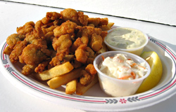
APPETIZERS
Clams on the Half Shell (Raw)*
Dozen.....$13.00 Half Dozen.....$8.00
Shrimp Cockail ..... $8.00
Cajun Popcorn Shrimp.....$6.50
Crab Cakes (2).....$7.00

CHOWDERS
New England Clam Chowder.....Cup...$4.50.....Bowl...$5.50
Manhattan Clam Chowder.....Cup...$4.50.....Bowl...$5.50
Spicy Crab and Sweetcorn Chowder.....Cup...$6.50.....Bowl...$8.00

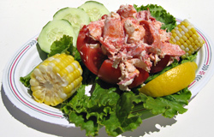
ENTREES
Steamed Mussels.....$13.50
Steamed Lobster....Market Price
Lobster Salad Roll.....Market Price
Fried Clam Strips.....$8.00
Fried Clam Roll.....$6.00
Fish and Chips.....$13.50
Fish'wich.....$6.50
Fried Whole Clams with Fries.....$16.50
Fried Shrimp with Fries.....$13.50
Fried Oysters with Fries.....$13.50
Fried Scallops with Fries.....$13.50
Grillied Chicken Sandwich with Fries.....$9.00
Grilled Veggie Burger with Salad Greens.....$9.00
Chicken Nuggets with Fries......$7.00
Crab Cakes (3) with Fries.....$12.50
Hamburger*.....$5.00
Cheeseburger*.....$5.50
Hot Dog.....$3.00

SIDES
French Fries.....$3.00
Sweet Potato Fries.....$3.50
Coleslaw.....$2.50
Local Corn on the Cob.....$3.00

*Consuming raw or undercooked meats, fish, shellfish or fresh shell eggs may increase your risk of food-borne illness, especially if you have certain medical conditions.

Only Cash or Traveler's Checks Accepted, ATM on premises.

LUNCH & DINNER DAILY
TAKE OUT ORDERS
631-267-6348

ASK ABOUT OUR DAILY SPECIALS!

