11.95Zuppa Di Cozze
New Zealand mussels in a brothy marinara sauce

11.95Zuppa Di Vongole
Little neck clams in a brothy marinara sauce

11.95Antipasto Caldo
Stuffed mushrooms, peppers, zucchini, eggplant rollatine, shrimps,
clams and mussels in a light sauce

9.95Vongole Orreganata
Baked clams 8pcs.

10.95Melone Con Prosciutto
Honey dew melon with imported parma posciutto

10.95Calamari Fritti
Fried calamari served with hot spicy red sauce

11.95Torta Primavera (click to view)
Several layers of crepes with a variety of vegetables, cheese and
meat fillings

13.95Cocktail Di Gamberi
Shrimp cocktail

11.95Cre Spelle Ai Funghi (click to view)
Crepes filled with wild mushrooms in cognac and bachamel sauce

8.95Chef's Salad
Fresh garden salad with vegetables cheese and meats

8.95Masculin Salad
Organic Salad

8.95Insalata Tricolore
Arrugula, endive, radicchio salad

8.95Caeser Salad (click to view)
Freshly tossed salad served with a tangy caeser dressing

8.95Insalata Di Spinaci
Fresh spinach with mushrooms and crispy bacon

7.95Insalata Mista
Fresh garden salad with vegetables

5.95Stracciatella Alla Romana
Eggdrop consomme with spinach

7.95Tagliolini Con Fagioli (click to view)
Home made pasta with beans

5.95Minestrone
Fresh vegetable soup

7.95Tortellini in Brodo
Consomme with tortellini

7.95Escarola Con Fagioli
Escarole soup with beans

15.95Capelli D Angelo Al Pesto
Home made angel's hair with basil, parsley, pine nuts, garlic oil and goat cheese

17.95Rigatoni Gismondi
Smoked salmon, onions, marinara sauce and a touch of cream, flambe' with vodka

15.95Tortellini Bolognese
Meat tortellini with meat sauce

15.95Fettuccine Al Filetto Di Pomodoro
Home made noodles with tomatoes, garlic and basil

17.95Penne Cognac (click to view)
Ham, chopped onions, cream, light marinara sauce, all flambe' with cognac

15.95Linguine Con Vongole
White or red calm sauce

23.95Seafood Ravioli
In a pink shrimp sauce

15.95Spaghetti Carbonara
Bacon, onions, cream parmigiano cheese and egg yolk

15.95Fettuccine Alfredo
Home made noodles in a creamy sauce

15.95Rigatoni Siciliana
Tomatoes, eggplant, garlic, basil and a touch of fresh mozzarella

17.95Cavatelli Con Rape (click to view)
Broccoli rape, garlic, sausage, pignoli nuts and beans

23.95Risotto Al Frutti Di Mare (click to view)
Shrimps, scallops, calamari, mussels, clams, sauteed with garlic and oregano

19.95Risotto Con Porcini
Wild mushrooms from Italy Sauteed with shallots, and a touch of tomatoes

46.95Risotto Con Tartufo
With black truffles and consomme

24.95Snapper Bonne Femme
Fillet of snapper in a white wine sauce with mushrooms, olives, garlic, lemon, butter, rosemary

21.95Sogliola Al Vino Bianco
Fresh fillet of sole broiled in a white wine with lemon and garlic

24.95Salmone Alla Griglia
Grilled Norwegian salmon

35.95Code D' Aragosta Alla Griglia
South African lobster tails broiled with butter

24.95Crabmeat Crepe Arturo
Stuffed with chilean creabmeat in a besciamelle sauce

24.95Gamberi Agli Scampi
Shrimp scampi with white wine, garlic and butter served on a bed of rice

24.95Gamberi Arturo
Shrimp with beans, garlic, fresh tomatoes in a wine sauce

24.95Coda D' Aragosta Alla Fiorentina
South African lobster tail dipped in batter and sauteed in a white wine sauce served on a bed of spinach

21.95Scaloppina Di Vitello All'Arturo
Veal with wine sauce topped with a slice of prosciutto and melted fontina cheese

21.95Scaloppina Di Vitello Al Marsala Con Funghi
Veal sauteed with marsala wine and mushrooms

21.95Saltimbocca Alla Fiorentina
Veal in white wine sauce topped with sage, a slice of prosciutto, and melted mozzarella cheese, served on a bed of spinach

21.95Scaloppina Di Vitello Alla Francese
Veal dipped in batter and sauteed in white a white wine with lemon and butter

21.95Cotoletta Parmigiana
Breaded veal cutlet with tomato sauce, parmigiano cheese and topped with melted mozzarella

35.95Ossobuco Milanese (click to view)
Veal shank served on saffron risotto

35.95Costata Di Vitello Alla Griglia
Grilled veal chop

35.95Costata Di Vitello Alla Milanese
Veal chop pounded, breaded, topped with tricolor salad

35.95Filetto Di Manzo All' Arturo (click to view)
Filet mignon in a cognac sauce with mushrooms

35.95Bistecca Alla Pizzaiola
Sirloin steak with peppers, mushrooms in a tomato sauce with garlic, oregano basil

33.95Costoletta D'Agnello Alla Griglia
Grilled lamb chops

17.95Pollo Alla Sorrentina
Chicken breast topped with a slice of eggplant prosciutto melted mozzarella cheese with mushrooms and peas in a wine sauce

16.95Pollo Al Vino Bianco
Chicken breast with white wine sauce and rosemary

16.95Pollo Alla Romana
Chicken breast with peppers, mushrooms and tomatoes

17.95Pollo Portafoglio Con Funghi
Chicken breasts stuffed with prosciutto and mozzarella cheese in a light tomato sauce and mushrooms

8.95Broccoli Di Rapa (Sauteed)

7.95Aparagus (Sauteed or steamed)

6.95Spinach (Sauteed or steamed)

6.95Escarole (Sauteed or steamed)

6.95Potato Crockets

4.95French Fries

6.95Fried Zucchini

6.95Dolci Arturo'
Home made desserts from the rolling cart

6.95Gelati
Vanilla and chocolate ice cream

7.95Tartufo
Truffle ice cream

7.95Fragole
Fresh strawberries

22.50Zabaglione Per Due For Two (click to view)
Hot marsala custard served on vanilla ice cream and strawberries

2.75Tea
Regular and decaffeinated and herbal

2.75Coffee
Regular and decaffeinated

3.25Espresso
Regular and decaffeinated

4.25Cappuccino
Regular and decaffeinated

11.95Caffe Romano (click to view)
Espresso with Sambuca, Galliano, Amaretto and whipped cream

11.95Irish Coffee
Coffee with Irish whiskey and whipped cream
- 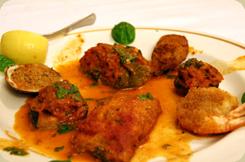
Antipasto Caldo
- 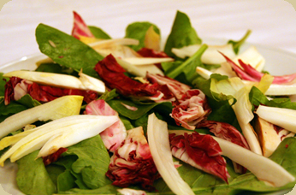
Insalata Tricolore
- 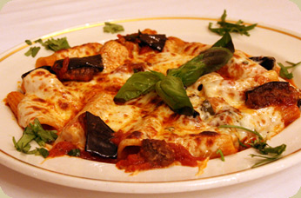
Rigatoni Siciliana
- 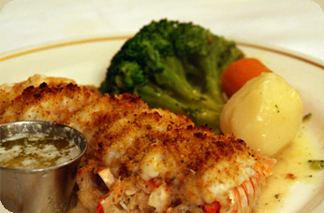
Langostino
- 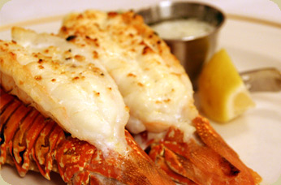
Code D' Aragosta Alla Griglia
- 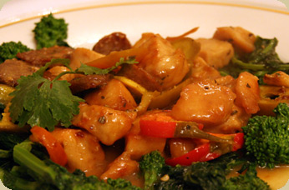
Chicken with Sausage and Brocoli Rape
- 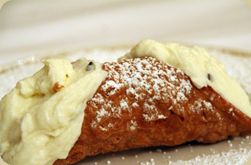
Conoli

