[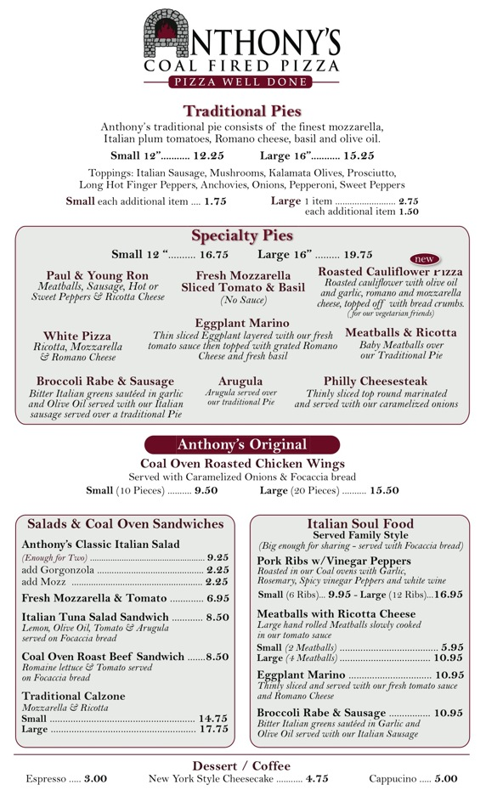](http://anthonyscoalfiredpizza.com/images/menu.pdf)