specials

starters

calamari 14
shallots, capers, garlic and light tomato sauce

mains

double pheasant 34
french couscous and mushroom sauce
starters

seafood gumbo 12

shrimp ceviche 16
grapefruit, oranges, poblano peppers, cilantro
and citrus vinaigrette

stuffed quail 16
white bean salad, sun-dried tomatoes
and natural jus

warm duck confit and serrano ham salad 13
baby arugula and tangerine vinaigrette

oysters rubio 14
crispy oysters, sauteed spinach, sweet plantain fufu
and wua kah tie sauce

beef empanadas 14
black bean salsa, daikon sprouts and romesco sauce

salad of baby organic greens 8
shaved parmesan cheese and fresh herb vinaigrette

baby spinach salad 9
cabrales blue cheese, roasted pear, black mission figs
and walnut vinaigrette

arugula and watercress salad 12
goat cheese, roasted butternut squash, pomegranate fruit,
crispy pumpkin seeds and raspberry vinaigrette
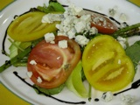
heirloom tomato salad
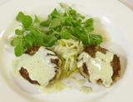
crab cakes
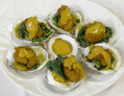
oysters rubio
CHACHAMA GRILL
$26 prix fixe

1

white bean soup
serrano ham and olive oil

salad of baby organic greens
cherry tomatoes and shallot vinaigrette

angel hair pasta
cherry tomatoes, spinach, shallots, shiitake mushrooms
and light tomato sauce

2

free range chicken
rice, olive relish and rosemary jus

tilapia
herb basmati rice and tomato-mixed olives concasse

shrimp asparagus ravioli
sauteed spinach, shiitake mushrooms and beurre blanc

3

napoleon
vanilla whip cream, fresh berries and grand marnier sauce

warm chocolate cake
vanilla ice cream and raspberry coulis

coconut flan
caramel sauce
dinner menu
Two prix fixe
menu options

$26 prix fixe
This menu is available all night from Sunday through Thursday only.

$38 prix fixe
This menu is available every day and all night. It includes any starter, any main and any dessert (coffee, tea, espresso and cappuccino are not included and some surcharges may apply).

updated Jan 9, 2012
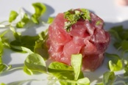
tuna ceviche
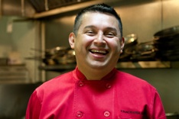
Chef Elmer Rubio

desserts 7

napoleon
vanilla whipped cream, fresh berries and grand marnier sauce

warm chocolate cake
vanilla ice cream and raspberry coulis

tiramisu
lady fingers, espresso, rum and mascarpone

pumpkin bread pudding
pumpkin ice cream and creme anglaise

crème brulée

poached pear
mixed berries compote and vaniila whipped cream

coconut flan
caramel sauce

fruit plate
mango sorbet and raspberry coulis

ice creams
vanilla chocolate caramel pumpkin

sorbets
mango lemon pineapple raspberry

coffee, decaffeinated coffee, tea, herbal tea,
espresso or cappuccino

